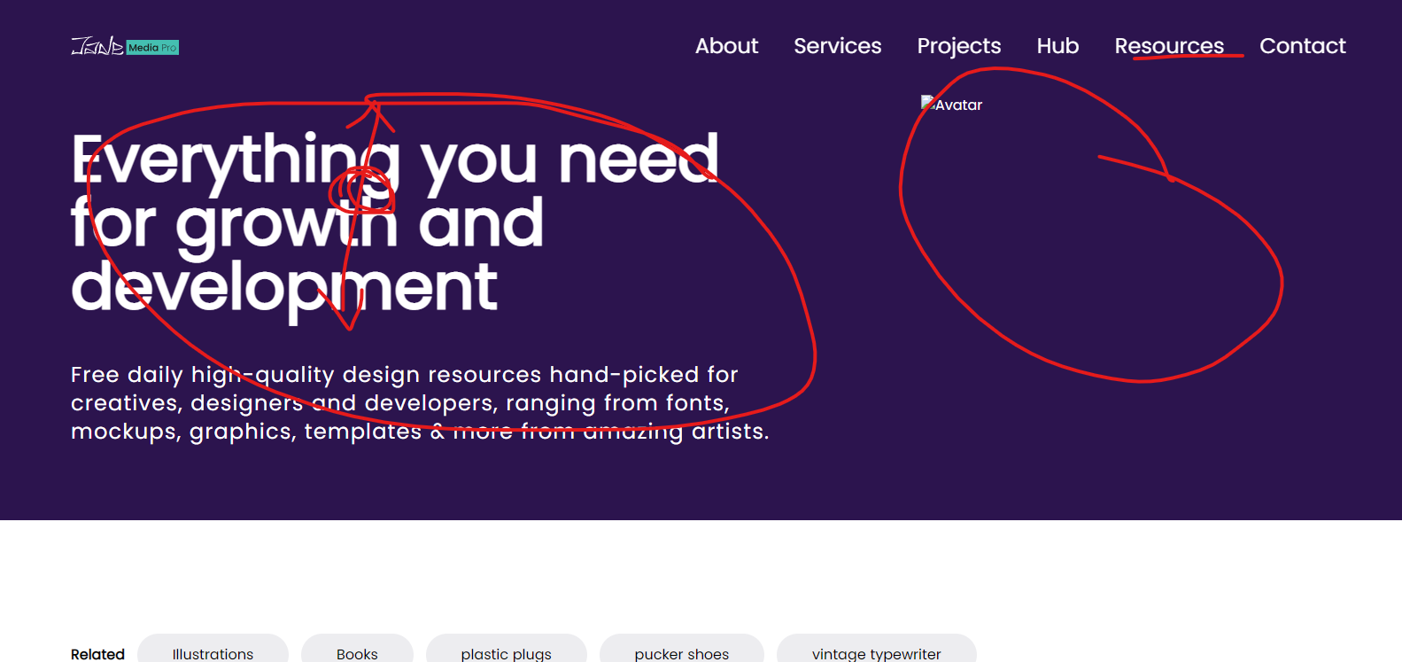

“Resources” bold effect and the line interaction.

The headline text height spacing.

Original illustration for all headers available in the fie provided.

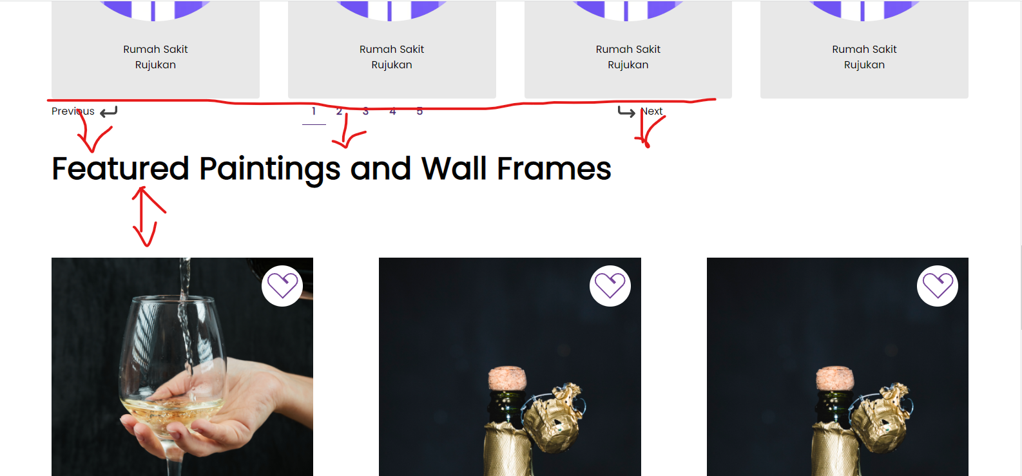

Appropriate spacing to be consistent throughout other pages.

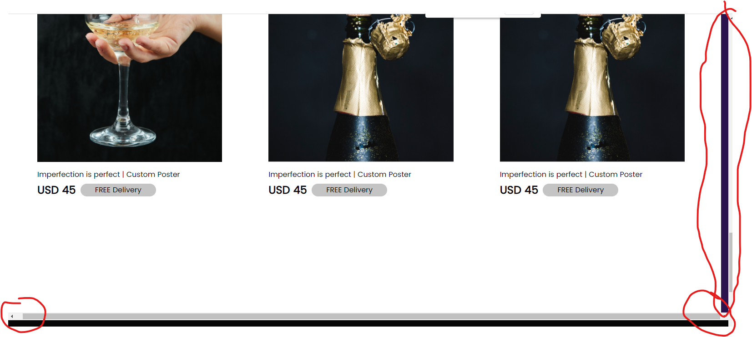

This came out of nowhere, there seems to be an horizontal scrollbar… the page seems extended. Please check.